Sri Lanka Institute of Information

Technology



Lab Submission

Lab sheet No 07

**IT24300116**

**Anjana W.A.N.**

**IT2120 - Probability and Statistics**

B.Sc. (Hons) in Information Technology

**Exercise**

**1**. A train arrives at a station uniformly between 8:00 a.m. and 8:40 a.m. Let the

random variable X represent the number of minutes the train arrives after 8:00

a.m. What is the probability that the train arrives between 8:10 a.m. and 8:25

a.m.?

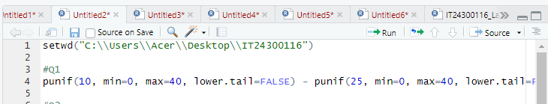

**Answer: -**

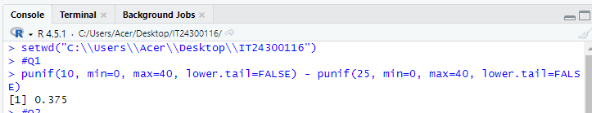

2.The time (in hours) to complete a software update is exponentially distributed

with rate λ = 1/3. Find the probability that an update will take at most 2 hours.



Answer: -



3. Suppose IQ scores are normally distributed with a mean of 100 and a

standard deviation of 15.

i. What is the probability that a randomly selected person has an IQ

above 130?



Answer: -



ii. What IQ score represents the 95th percentile?



Answer: -

